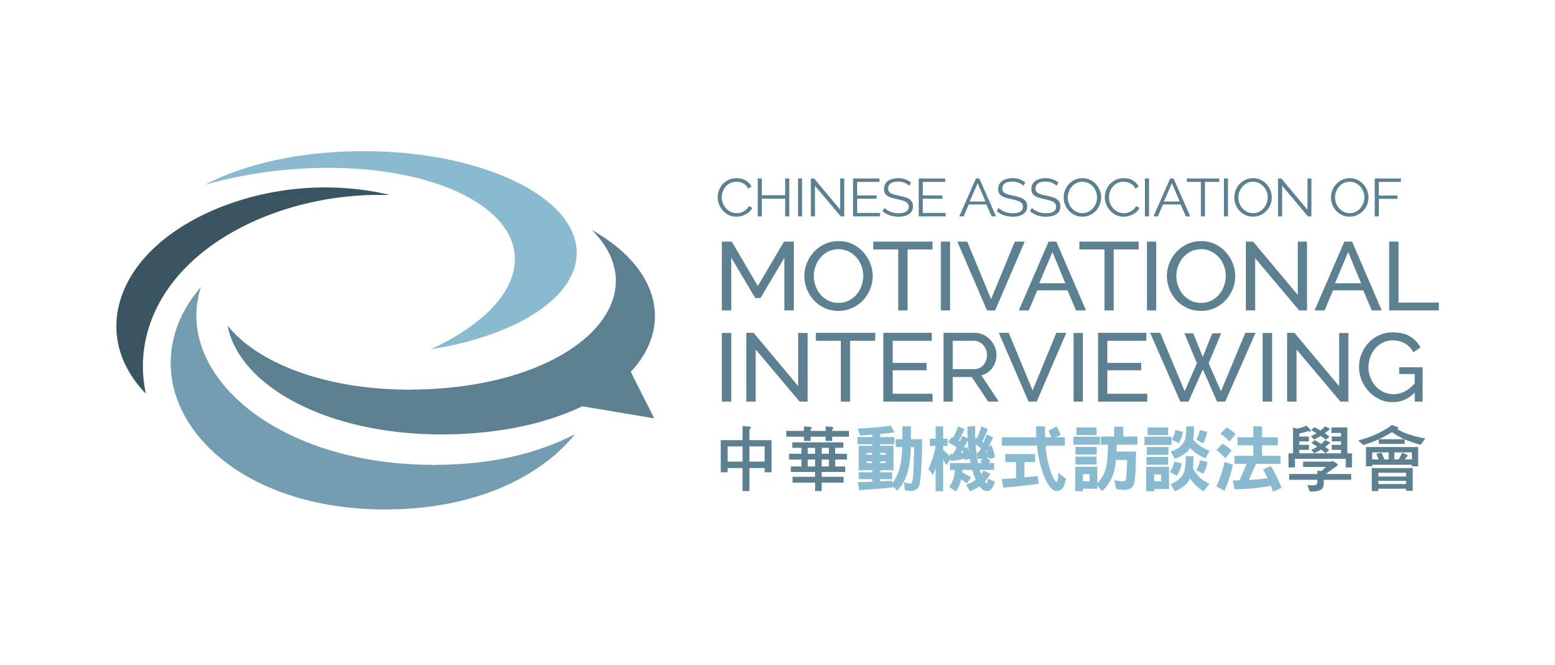
Chinese Association of Motivational Interviewing Limited
Membership Application Form (v.13_2324_eng)

(Please tick “” where appropriate)
- New Application
- *Renewal: Membership No.:
*Please fill in Part A/B/C if there is change of Personal Information
- Personal Details:
Title: Prof. / Dr / Mr / Mrs / Ms / Miss
Surname: Given Name: Name in Chinese:
Phone Number: Email:
Mailing Address:
Gender: Male Female

- Current Employment in:
- Health Care Social Welfare
- Education Counselling or Clinical Psychology
- Correctional Others: (please specify)
- Education Level:
- Doctorate Dip./ High Dip.
- Master Secondary
- Bachelor

Membership Type and Subscription Fee:
By crossed cheque payable to “Chinese Association of Motivational Interviewing Limited”
Please write your name and contact telephone number on the back of the cheque.
- Life member : $ 2,000
Full for 2 years with expiration on 31st March 2025 : $ 500
- Full for 1 year with expiration on 31st March 2024 : $ 300
- Student for 1 year with expiration on 31st March 2024 : $ 200
(please submit together with copy of your full time student card)

Cheque enclosed: Bank: No.: Amount:

□ I object the Association to use my personal data for member-related communication
□ I object the Association to use my personal data for training promotion.
Declaration:
I declare that all the above information and all substantial documents are true and correct and I further understand that any dishonesty or false representation on this form will lead to disqualification.

Signature: Date:

Remarks:
Please send completed application form, together with related documents if needed and a crossed cheque for the annual subscription fee to:

Attn: Chinese Association of Motivational Interviewing Limited

Unit 2305 Apec Plaza
49 Hoi Yuen Road
Kwun Tong
Hong Kong
(Re: CAMI Membership)

- The Executive Committee will vet all applications.
- Cheque will be returned, together with submitted form, to the applicant if application is NOT accepted.
- The processing time may take 6 weeks. You will be notified about the result by email. If you have any questions about the application, please write to info@cami.hk

Notice to Data Subject Regarding Personal Data Disclosed to
Chinese Association of Motivational Interviewing Limited
The personal data provided by you will be accessible only to those persons who are directly involved in the operation of the Association. They are required to observe the rule of confidentiality under the Personal Data (Privacy) Ordinance and other relevant ordinances. Personal data are only disclosed when the Executive Committee authorizes such disclose. You have right of access to and correction of personal data held on you by the Association.

For official Use only:
Date received | Apply / Renewal | Cheque no. | Checked on | Vetting on | Membership No. | Reply on | Receipt No.
 | Life / 2-year Full / 1-year Full / Student

